**NAVIGATION BARS**

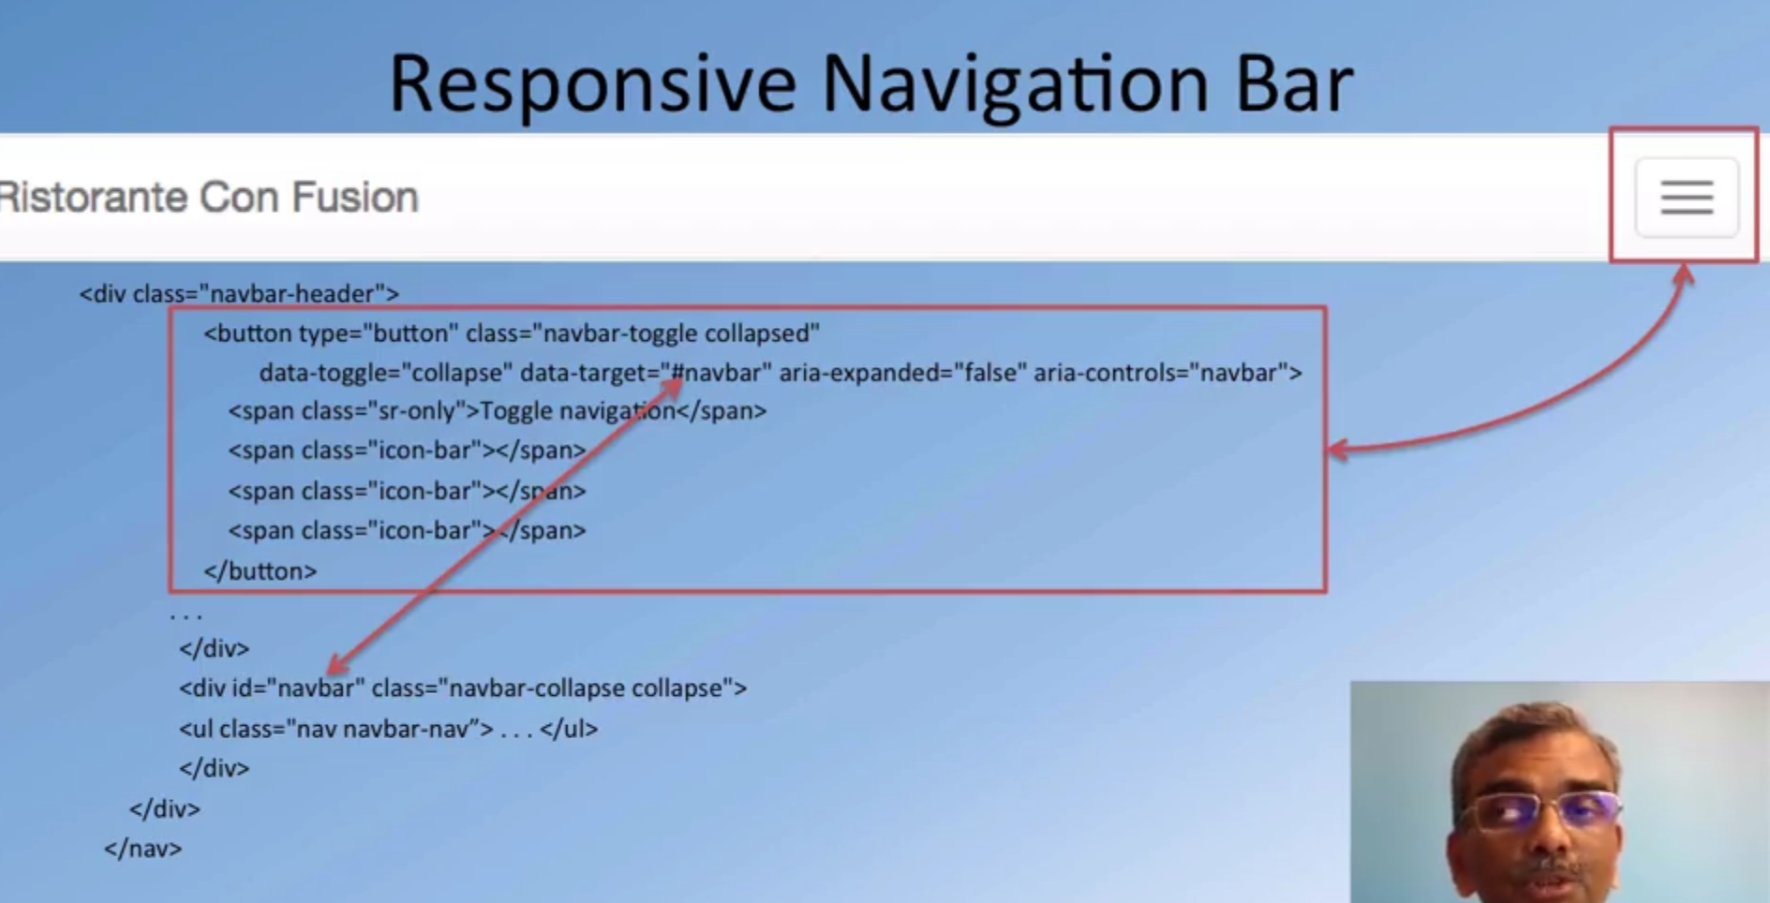

**Dropdown**

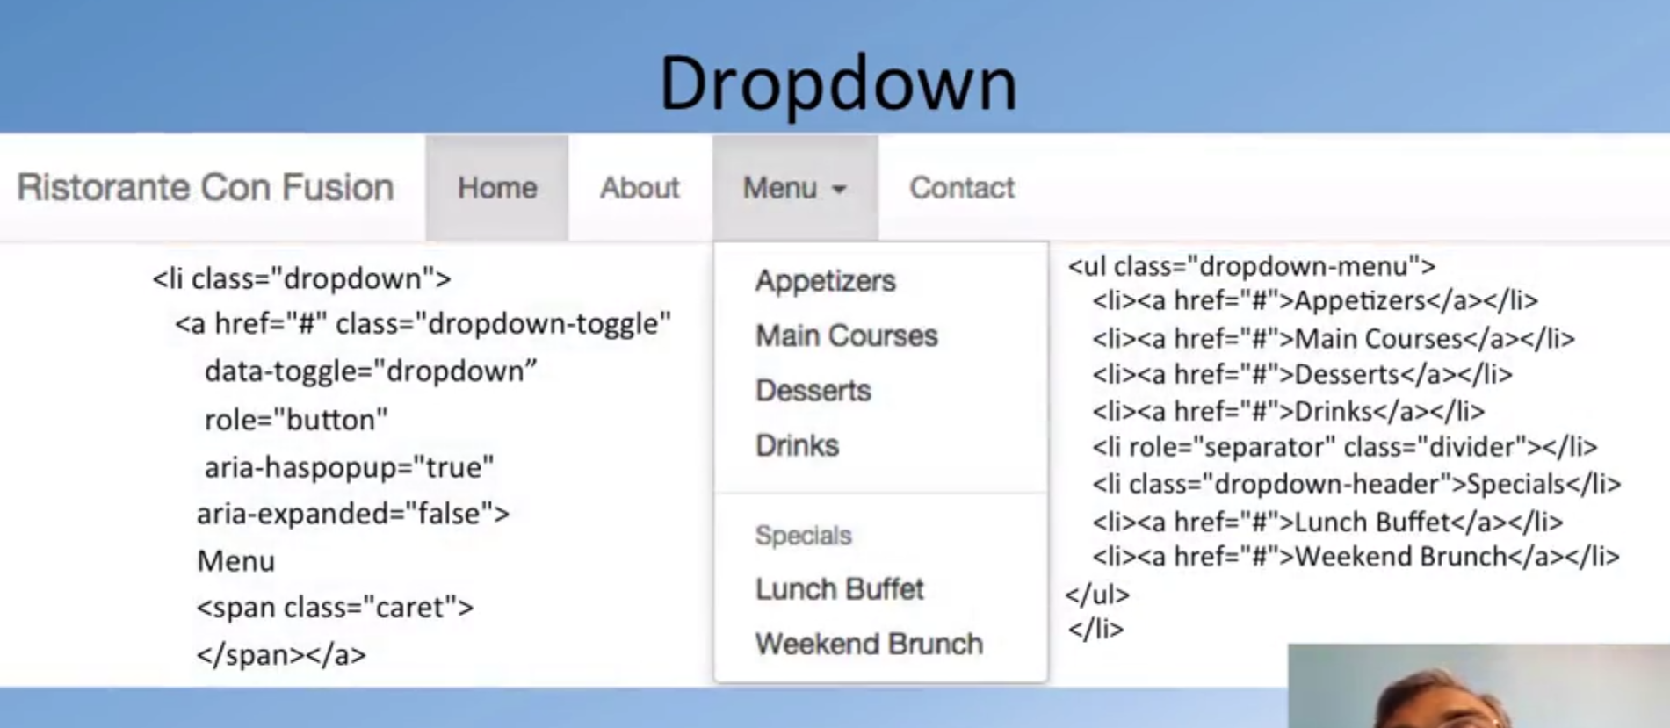

span class=”caret” shows the triange near menu.

<nav class="navbar navbar-inverse navbar-fixed-top" role="navigation"> **//will appear at the top of the page(will scroll)**

<div class="container">

<ul class="nav navbar-nav">

<li class="active"><a href="#">Home</a></li> **//highlighted the home**

<li><a href="#">About</a></li>

<li><a href="#">Menu</a></li>

<li><a href="#">Contact</a></li>

</ul>

</div>

</nav>

**Creates basic menu**



<nav class="navbar navbar-inverse navbar-fixed-top" role="navigation">

<div class="container">

**<div class="navbar-header">**

**<button type="button" class="navbar-toggle collapsed" data-toggle="collapse" data-target="#navbar" aria-expanded="false" aria-controls="navbar">**

**<span class="sr-only">Toggle navigation</span>**

**<span class="icon-bar"></span>**

**<span class="icon-bar"></span>**

**<span class="icon-bar"></span>**

**</button>**

**<a class="navbar-brand" href="#">Ristorante Con Fusion</a>**

**</div>**

<div id="navbar" class="navbar-collapse collapse">

<ul class="nav navbar-nav">

<li class="active"><a href="#">Home</a></li>

<li><a href="#">About</a></li>

<li><a href="#">Menu</a></li>

<li><a href="#">Contact</a></li>

</ul>

</div>

</div>

</nav>

**Result**

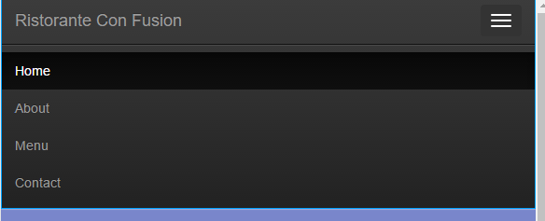

**By replacing the “menu” item with**

<li class="dropdown">

<a href="#" class="dropdown-toggle" data-toggle="dropdown"

role="button" aria-haspopup="true" aria-expanded="false">

Menu <span class="caret"></span></a>

<ul class="dropdown-menu">

<li><a href="#">Appetizers</a></li>

<li><a href="#">Main Courses</a></li>

<li><a href="#">Desserts</a></li>

<li><a href="#">Drinks</a></li>

<li role="separator" class="divider"></li>

<li class="dropdown-header">Specials</li>

<li><a href="#">Lunch Buffet</a></li>

<li><a href="#">Weekend Brunch</a></li>

</ul>

</li>

**I get a dropdown menu that looks like**

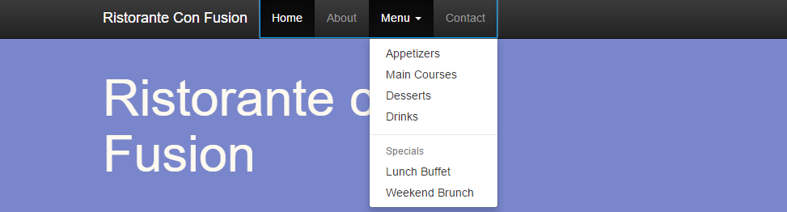

<li class="active"><a href="#"><span class="glyphicon glyphicon-home"

aria-hidden="true"></span> Home</a></li>

**Adds the home icon to the button**

<i class="fa fa-phone"></i>: +852 1234 5678<br>

<i class="fa fa-fax"></i>: +852 8765 4321<br>

<i class="fa fa-envelope"></i>:

<a href="mailto:confusion@food.net">[confusion@food.net</a](mailto:confusion@food.net%3c/a)>

**Adds small icons to fax and envelope**

<div class="nav navbar-nav" style="padding: 40px 10px;">

<a class="btn btn-social-icon btn-google-plus" href="http://google.com/+"><i class="fa fa-google-plus"></i></a>

<a class="btn btn-social-icon btn-facebook" href="http://www.facebook.com/profile.php?id="><i class="fa fa-facebook"></i></a>

<a class="btn btn-social-icon btn-linkedin" href="http://www.linkedin.com/in/"><i class="fa fa-linkedin"></i></a>

<a class="btn btn-social-icon btn-twitter" href="http://twitter.com/"><i class="fa fa-twitter"></i></a>

<a class="btn btn-social-icon btn-youtube" href="http://youtube.com/"><i class="fa fa-youtube"></i></a>

<a class="btn btn-social-icon" href="mailto:"><i class="fa fa-envelope-o"></i></a>

</div>

**Makes the social link be buttons**